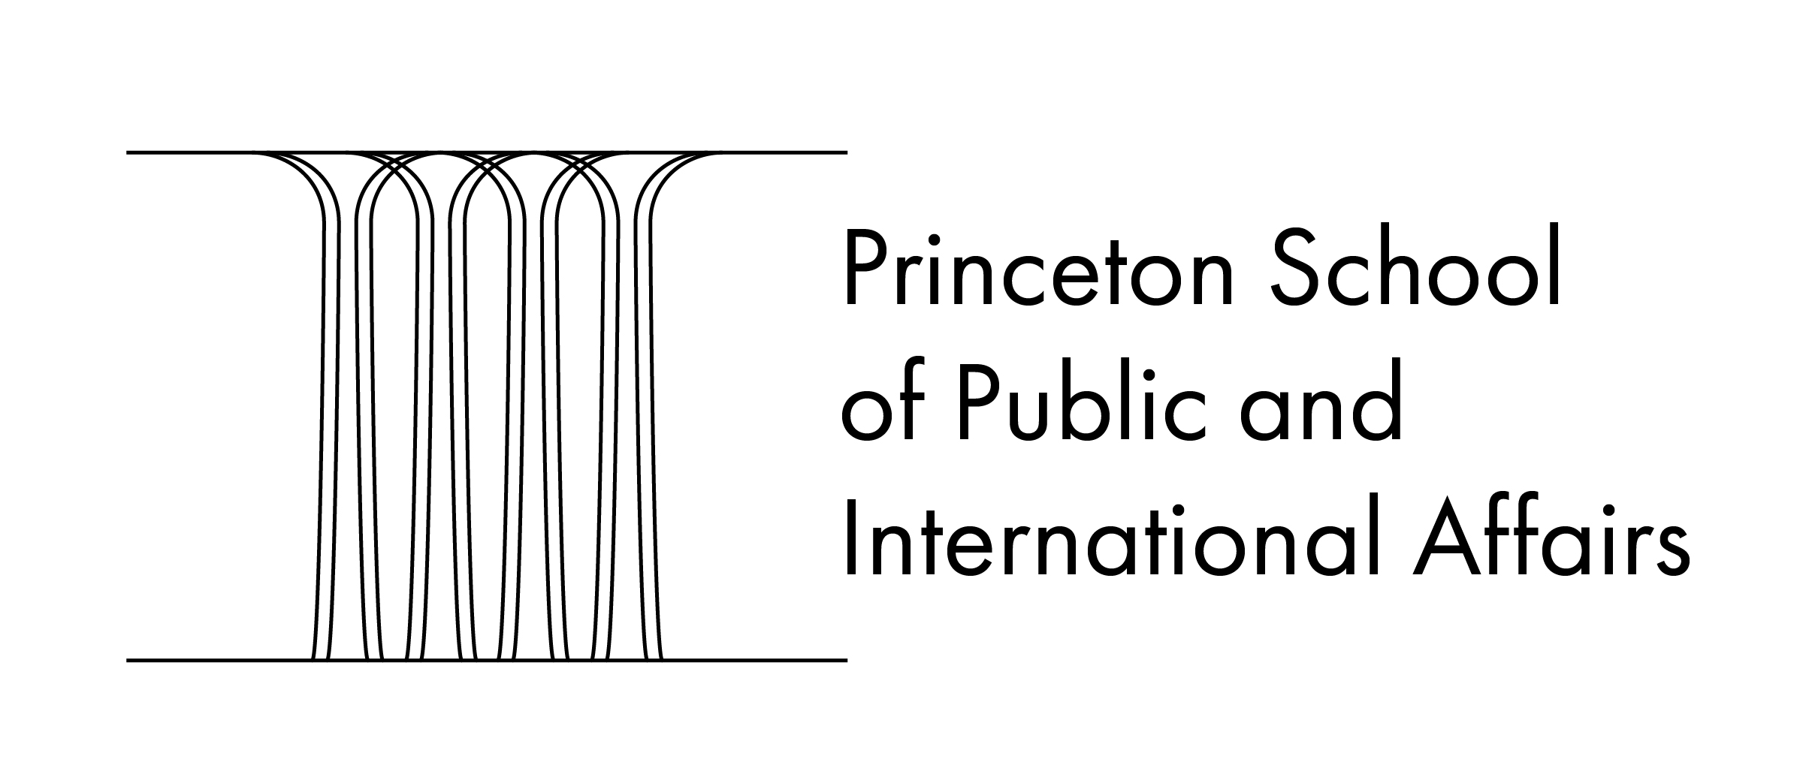

THESIS PROPOSAL FORM

This form should be filled out by the student and signed by both the student and the adviser. The form must be submitted to the Undergraduate Program Office as soon as the adviser agrees to supervise the thesis but no later than 12:00noon, on Friday, September 17th.

It confirms that the adviser has agreed to supervise the thesis as described. It is understood that each element of the thesis may need to change as the research and writing proceeds.

The thesis topic must be policy-focused and otherwise conform to the rules of the undergraduate program. If there is any problem with the topic, the student will be contacted by the program office.

Provide a brief thesis topic (in no more than 10 words).

______________________________________________________________________________

Briefly describe the topic:

Briefly state the research question:

Briefly state your current working hypothesis.

Briefly outline the nature of the research evidence that you expect to use to answer your question or test your hypothesis:

Do you plan to conduct interviews or surveys of human subjects for your thesis? Yes ( ) or No ( )

If yes, have you already reached out to IRB? Yes ( ) or No ( )

_________________________________ __________________________
Student name (please print) Student Signature

_________________________________ __________________________
Adviser’s Name (please print) Adviser’s Signature

