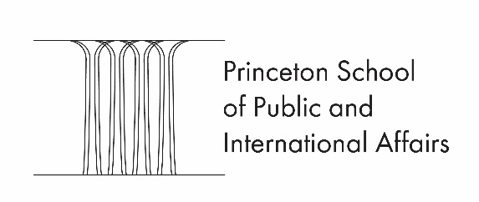

Public-Service Summer Internship Search

Please complete before November 10, junior year, attach your resume and return to Elizabeth Choe at liz.choe@princeton.edu. At the same time you can set up an appointment with her to explore internship opportunities.

Name: Class of: .

Date: Telephone Ext: E-mail: .

Check the field/s you are interested in:

Government/political Media Education Environment Law

Healthcare Relief Research Other (describe)

What type of internship are you looking for?

Domestic Abroad Full-time Part-time Large agency

Small agency Paid Unpaid Other (describe):

Please list any relevant experience (jobs, volunteering, international, etc.) and skills (languages, writing, computers, quantitative, etc.) that may not be apparent on your resume:

Are you already pursuing any promising leads? If so, please describe:

Other comments:

